Create a Customer group in admin.py

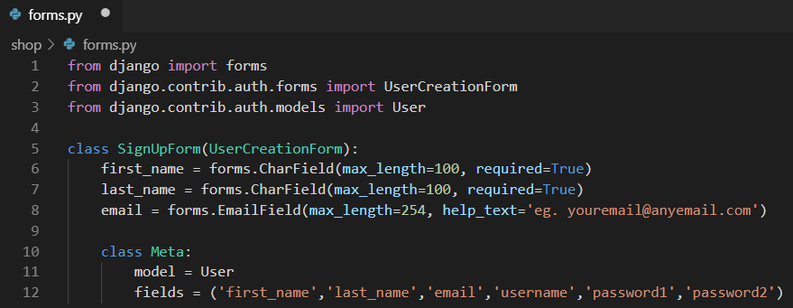

Open **shop/views.py** and add the following imports at the top of the file:

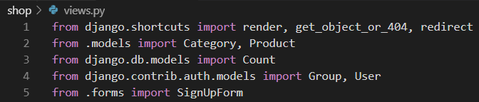

Add the following function to the same file:

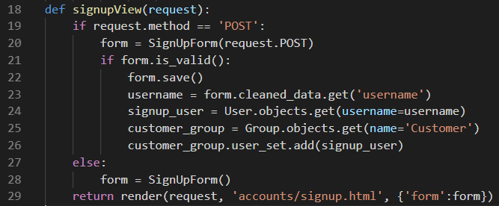

**Template**

Right click on the **shop/templates** folder and create a new folder called **accounts**. Go to your browser & access Moodle. Right click on the file called **signup.html** and choose the menu option “Save Link as”. Navigate to the accounts folder inside your project and click save.

**URL**

Open the project **urls.py** file and add the following code to map the route to the view:

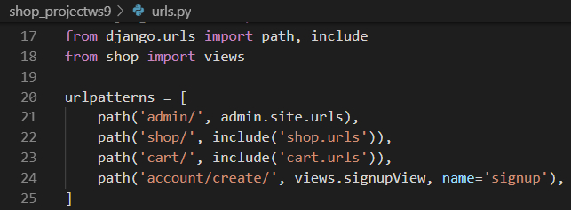

Settings.py



Bottom of settings.py



Signup.html









Save the file and open the terminal and restart the server

In the browser type the following url into the url bar URL bar:

<http://127.0.0.1:8000/account/create/>

Sign In

shop/views.py





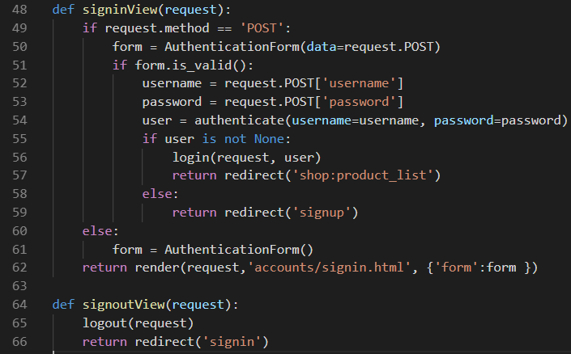

urls.py



Sign In Template - see notes above for signup

urls.py



Open the base.html file and add the block of code provided

